-- 10000010 Ludicrous, Forward, Pen Up

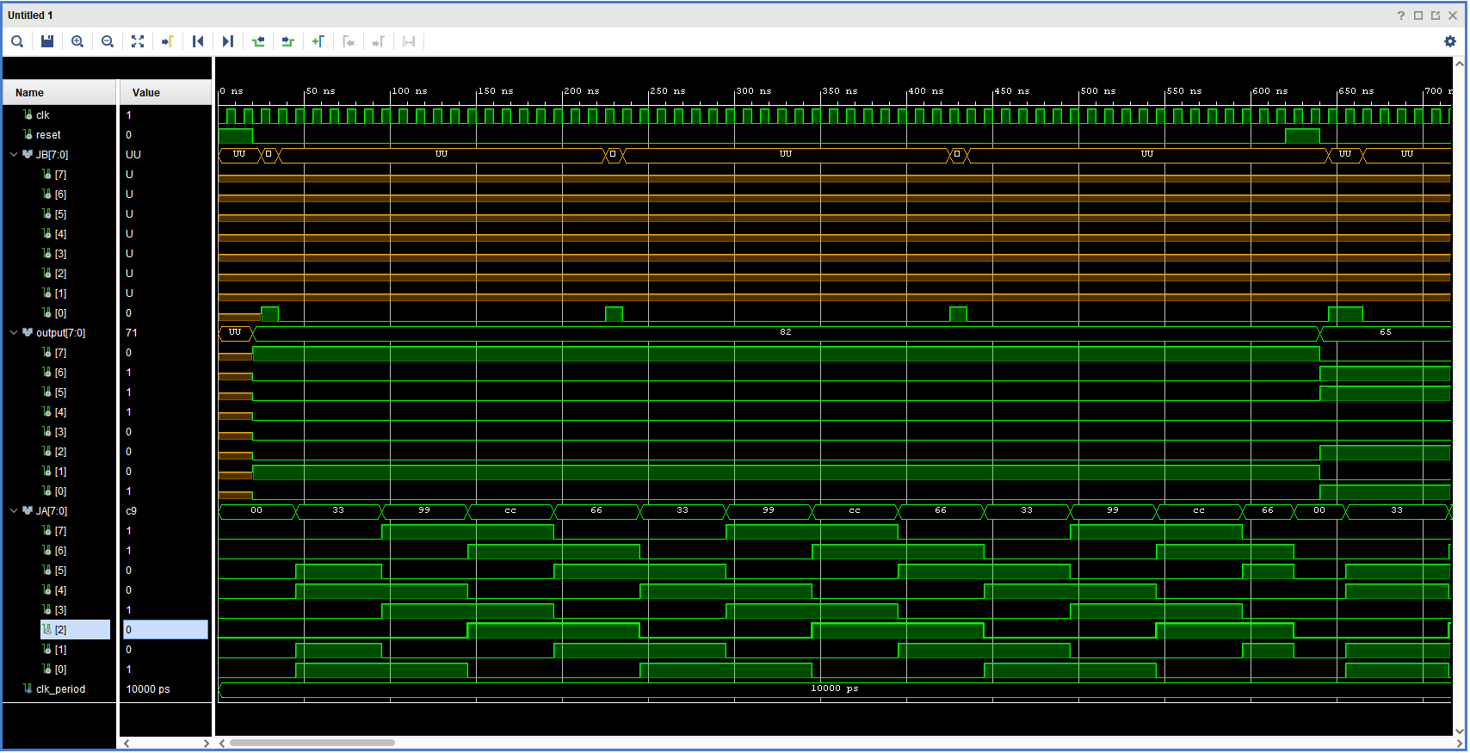

-- 01100101 Fast, Backward, Pen Down

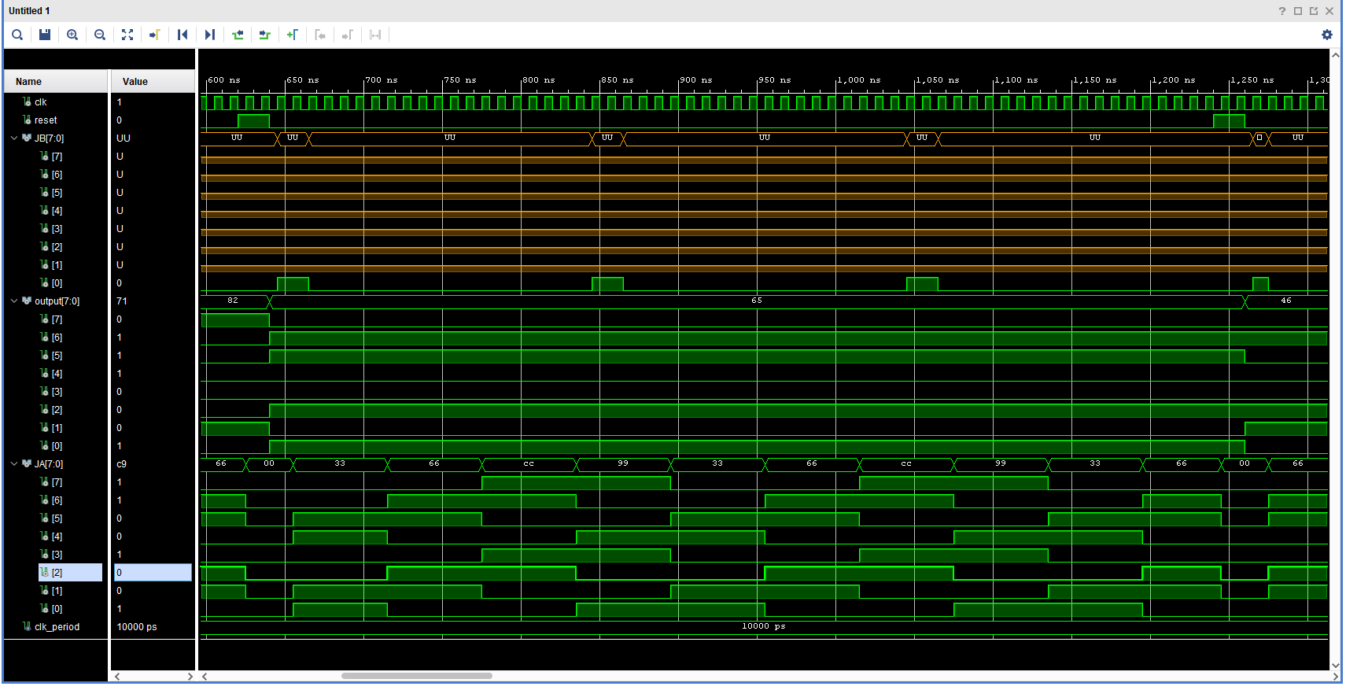

-- 01000110 Medium, Forward Right, Pen Up

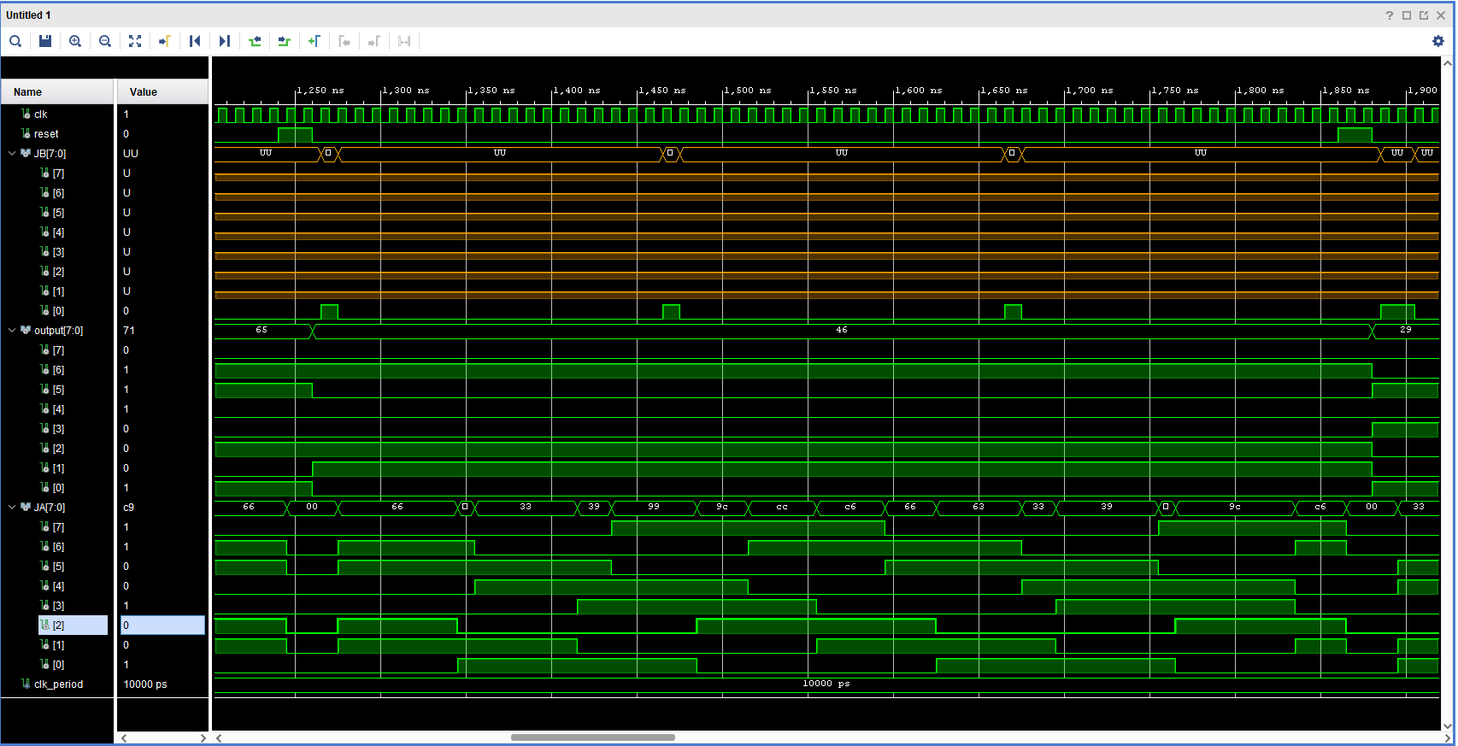

-- 00101001 Slow, Forward Left, Pen Down

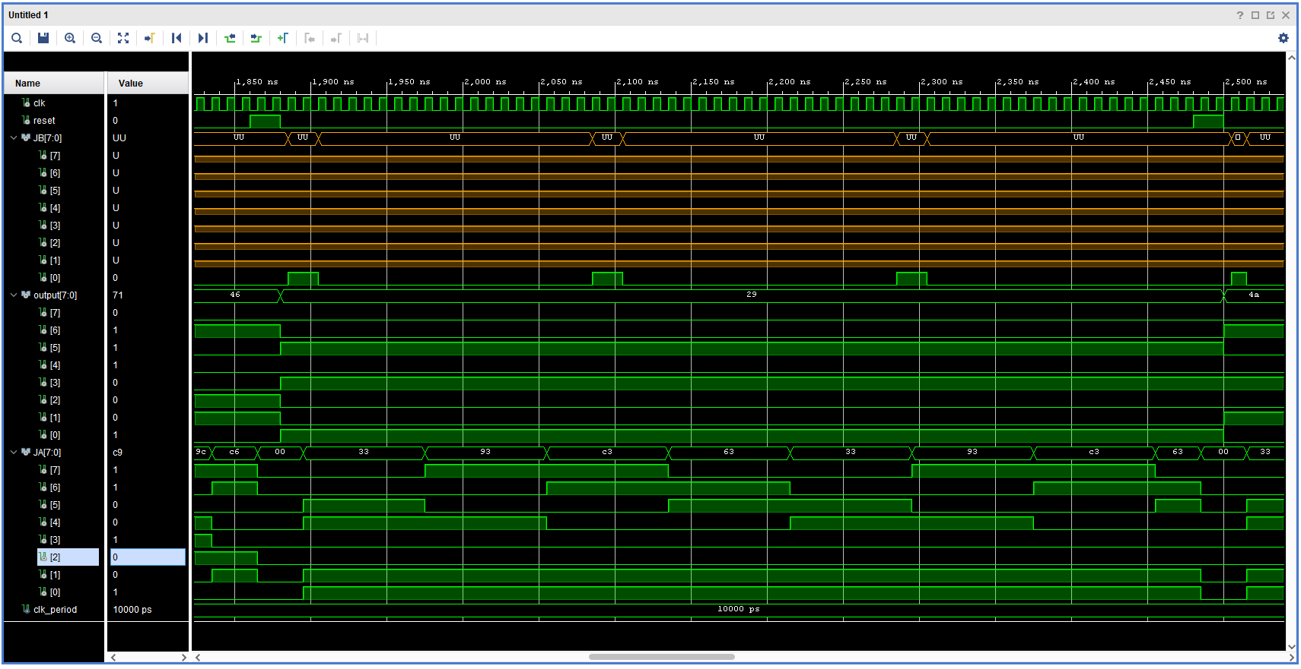

-- 01001010 Medium, Backward Right, Pen Up

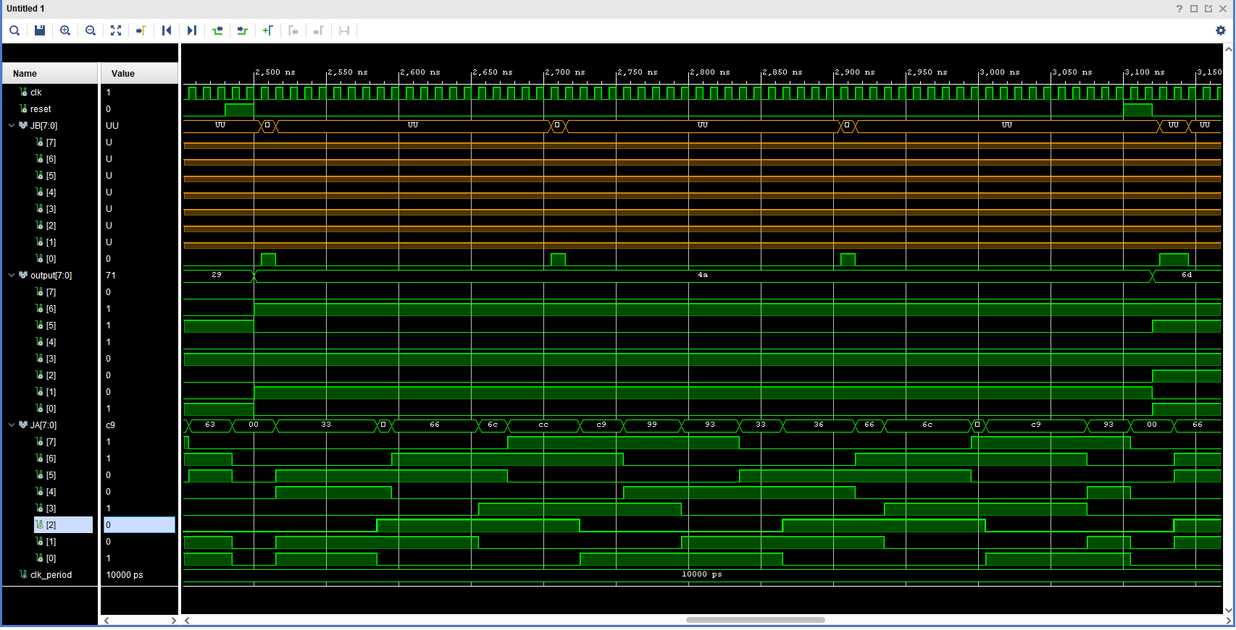

-- 01101101 Fast, Backward Left, Pen Down

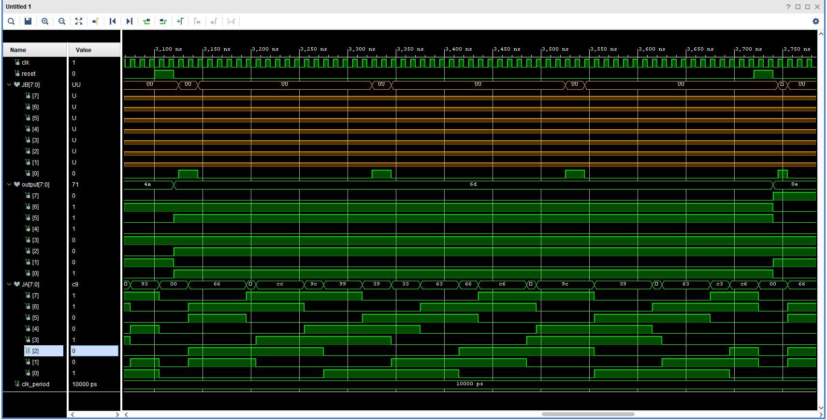

-- 10001110 Ludicrous, Rotate Right, Pen Up

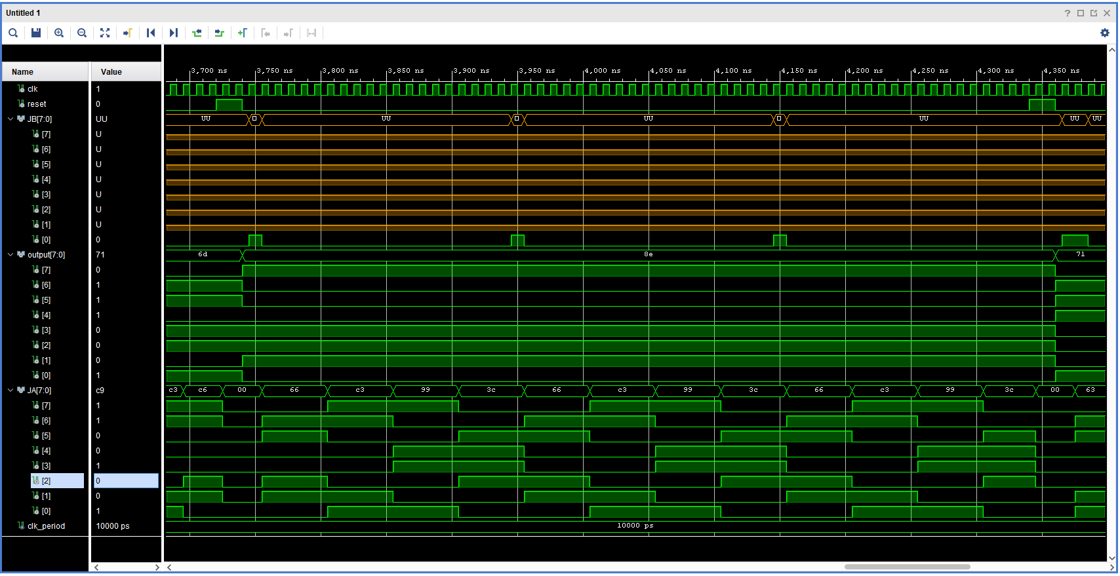

-- 01110001 Fast, Rotate Left, Pen Down

